Behavior-Driven Development (BDD)

What is Behavior-Driven Development (BDD)
# Source: Chatgpt (GPT-5-Standard) at [8/17/2025]
Behavior-Driven Development (BDD) is a collaboration-based testing and development approach that focuses on defining system behavior in a way that everyone can understand — developers, testers, and business stakeholders.
It extends Test-Driven Development (TDD) but emphasizes business value and shared understanding through natural language scenarios.

🔑 Key Ideas of BDD:
# Source: Chatgpt (GPT-5-Standard) at [8/17/2025]
- Focus on Behavior, Not Implementation
  - Instead of writing tests about how code works, you define what the system should do from a user’s perspective.
- Common Language (Ubiquitous Language)
  - Uses simple, structured natural language (often English) to describe behaviors, so non-technical stakeholders can understand.
- Collaboration
  - Encourages conversations among developers, testers, and business people before coding starts.
- Executable Specifications
  - Scenarios written in Gherkin syntax (Given–When–Then) double as both requirements and automated tests.

📖 Example of BDD Scenario (Gherkin)
# Source: Chatgpt (GPT-5-Standard) at [8/17/2025]
Feature: Withdraw money from an ATM
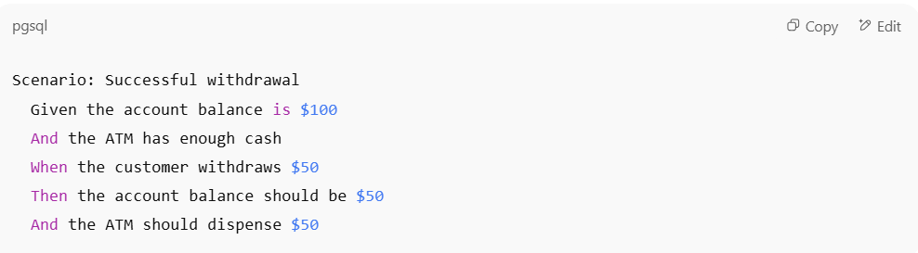
Scenario: Successful withdrawal
Given the account balance is $100
And the ATM has enough cash
When the customer withdraws $50
Then the account balance should be $50
And the ATM should dispense $50

- Given → initial context (preconditions)
- When → event/action by the user
- Then → expected outcome (postcondition)

✅ Benefits of BDD
# Source: Chatgpt (GPT-5-Standard) at [8/17/2025]
- Improves communication between business and technical teams.
- Reduces misunderstandings about requirements.
- Provides living documentation (scenarios are both readable and executable).
- Helps ensure the team is building the right features (aligned with business goals).
- Easier for non-technical stakeholders to validate correctness.

⚠️ Challenges
# Source: Chatgpt (GPT-5-Standard) at [8/17/2025]
- Needs discipline and collaboration — not just writing Gherkin blindly.
- Can become cumbersome if scenarios are poorly maintained.
- Requires the right tooling (e.g., Cucumber, SpecFlow, Behave).

⚖️ Summary:
# Source: Chatgpt (GPT-5-Standard) at [8/17/2025]
BDD = write tests in business-readable language (Given–When–Then) through collaboration, so tests become shared understanding, executable requirements, and living documentation.

